Project Planning Phase
Project Planning Template (Product Backlog, Sprint Planning, Stories, Story points)

Date | 15 February 2025
Team ID
Project Name | Import Data using Transform Maps (Spreadsheet)
Maximum Marks | 5 Marks

Product Backlog, Sprint Schedule, and Estimation (4 Marks)
Use the below template to create product backlog and sprint schedule
Sprint | Functional Requirement (Epic) | User Story Number | User Story / Task | Story Points | Priority | Team Members
Sprint-1 | Data Preparation | USN-1 | As an administrator, I can prepare a spreadsheet with Student ID, Name, Department, Email and Year. | 2 | High | Gobinath
Sprint-1 | Table Creation | USN-2 | As an administrator, I can create the Student Information table with its columns. | 3 | High | Gobinath
Sprint-1 | Data Import | USN-3 | As an administrator, I can load the spreadsheet into the import set table. | 2 | High | Gobinath
Sprint-1 |  | USN-4 | As an administrator, I can create a Transform Map and map the fields. | 3 | High | Gobinath
Sprint-2 | Data Transformation | USN-5 | As an administrator, I can run the transform and verify 5 inserts with 0 errors. | 2 | High | Gobinath
Sprint-2 | Reporting | USN-6 | As a user, I can view a pie chart report of student records. | 3 | Medium | Gobinath
Sprint-2 | Dashboard | USN-7 | As a user, I can view a dashboard with total count and trend chart. | 3 | Medium | Gobinath

Project Tracker, Velocity & Burndown Chart: (4 Marks)
Sprint | Total Story Points | Duration | Sprint Start Date | Sprint End Date (Planned) | Story Points Completed (as on Planned End Date) | Sprint Release Date (Actual)
Sprint-1 | 10 | 3 Days | 22 Sep 2026 | 24 Sep 2026 | 10 | 24 Sep 2026
Sprint-2 | 8 | 3 Days | 25 Sep 2026 | 27 Sep 2026 | 8 | 27 Sep 2026

Velocity:
Sprint duration = 3 days; total story points = 10 + 8 = 18 over 2 sprints, so the team velocity is 18 / 2 = 9 story points per sprint. Average velocity per day (AV) = 9 / 3 = 3 story points per day.
AV = Sprint velocity / Sprint duration = 9 / 3 = 3 story points per day

Burndown Chart:
A burn down chart is a graphical representation of work left to do versus time. It is often used in agile software development methodologies such as Scrum. However, burn down charts can be applied to any project containing measurable progress over time.
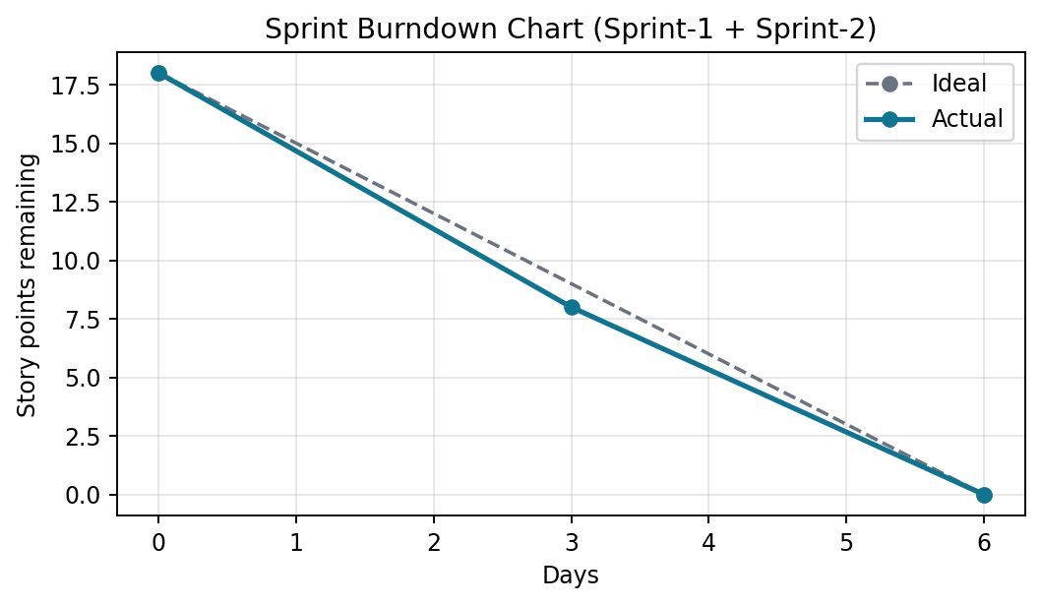

https://www.visual-paradigm.com/scrum/scrum-burndown-chart/
https://www.atlassian.com/agile/tutorials/burndown-charts

Reference:
https://www.atlassian.com/agile/project-management
https://www.atlassian.com/agile/tutorials/how-to-do-scrum-with-jira-software
https://www.atlassian.com/agile/tutorials/epics
https://www.atlassian.com/agile/tutorials/sprints
https://www.atlassian.com/agile/project-management/estimation
https://www.atlassian.com/agile/tutorials/burndown-charts

